Moynalty AC M4M2025

Thank you for registering for Moynalty AC's M4M 4 mile road race, we hope you are looking forward to taking part. Please see below some important race day information along with t-shirt / bib number collection time.

If you opted & paid to have your pack posted you should have received by now. If for some reason it has not arrived do not worry you can collect a replacement number on the morning and your original number will be deleted.

If you did not opt & pay for postage you will need to collect your number & t-shirt. (Please note t-shirt sizes are not guaranteed - as advised on registration form)

We also have participant list where you can check your details - club, category, collect or post etc. Please click HERE to view.
If your details need to be updated please email support@myrunresults.com

COLLECTION TIME & LOCATION
SUNDAY 10am - 12NOON - Threshing Field
MONDAY 10am - 11:30am - Threshing Field

RACE START
RACE START 12NOON SHARP
in the THRESHING FIELD - signed posted / directed by Marshals on-site.
AREAS will be marked out for those walking - at the back, runners to the front, 'elites' to the very front.

WARM-UP 11:45am at the START area
PARKING
ON-SITE in the THRESHING FIELD
Follow Marshals instructions. AMPLE parking in the field.
FACILITIES
PORT-A-LOOS on-site,
NO BAG DROP as parking in the field beside START.
No in-house entry to Threshing Field Museum
POST RACE
POST RACE refreshments externally on-site at FINISH AREA
Fruit, water, Tea, Coffee, cakes, etc.

PRIZE GIVING
ON-SITE after race completed and winners confirmed
TEAM PRIZES Male and Female:
1st Male team x first 3 over line, 1st Female team x first 3 over line

FIRST 3 MALES over line - 1st, 2nd, 3rd
FIRST 3 FEMALES over line - 1st, 2nd, 3rd
AGE Categories:
JUNIOR M and F – 1st and 2nd (up to aged 20)
Over 40 / 50 / 60 / 70 - 1st and 2nd in each category - Male and Female

Moynalty AC M4M RACE ROUTE 2025 – HQ A82 C6K7

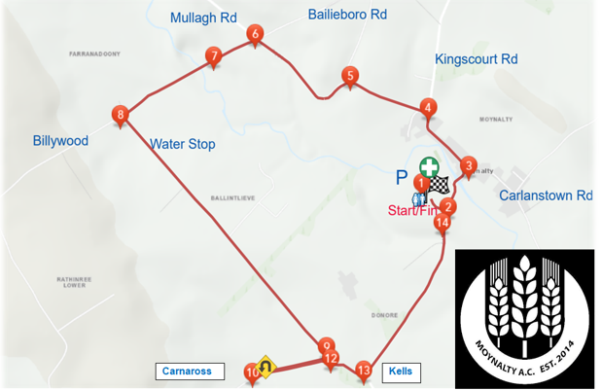

M4M2025 IS NOW SOLD OUT
NO WALK IN REGISTRATIONS ON THE DAY

